Cameron Sauvageau Engineering Notebook

Hardware Team

9/26/24:

Today I did about 2.5 hours of research on hardware and movement to get more familiar with the robot and what parts we should look into ordering. I did a lot of research into what parts work best together and how they would affect the overall performance of the robot.

9/27/24:

Today I did a little bit of research on materials. Focused on the robotic arm and what the best material would be to use if we made it ourselves. Didn't want it to be too heavy but durable so 3D printing would most likely be the best idea or to just order the arm already built.

10/03/24:

Today we had a meeting about the scope of our project. The Navy wants to get involved and want us to be able to track UAV instead of human life forms. This doesn't change too much on the hardware side except we would have to work with satellites now. I have never really worked with satellites so will definitely have to do some research. We also would not have a need for the robotic arm so no reason to order that right now or worry about it. Since we haven't been able to order parts, so we are starting to get behind.

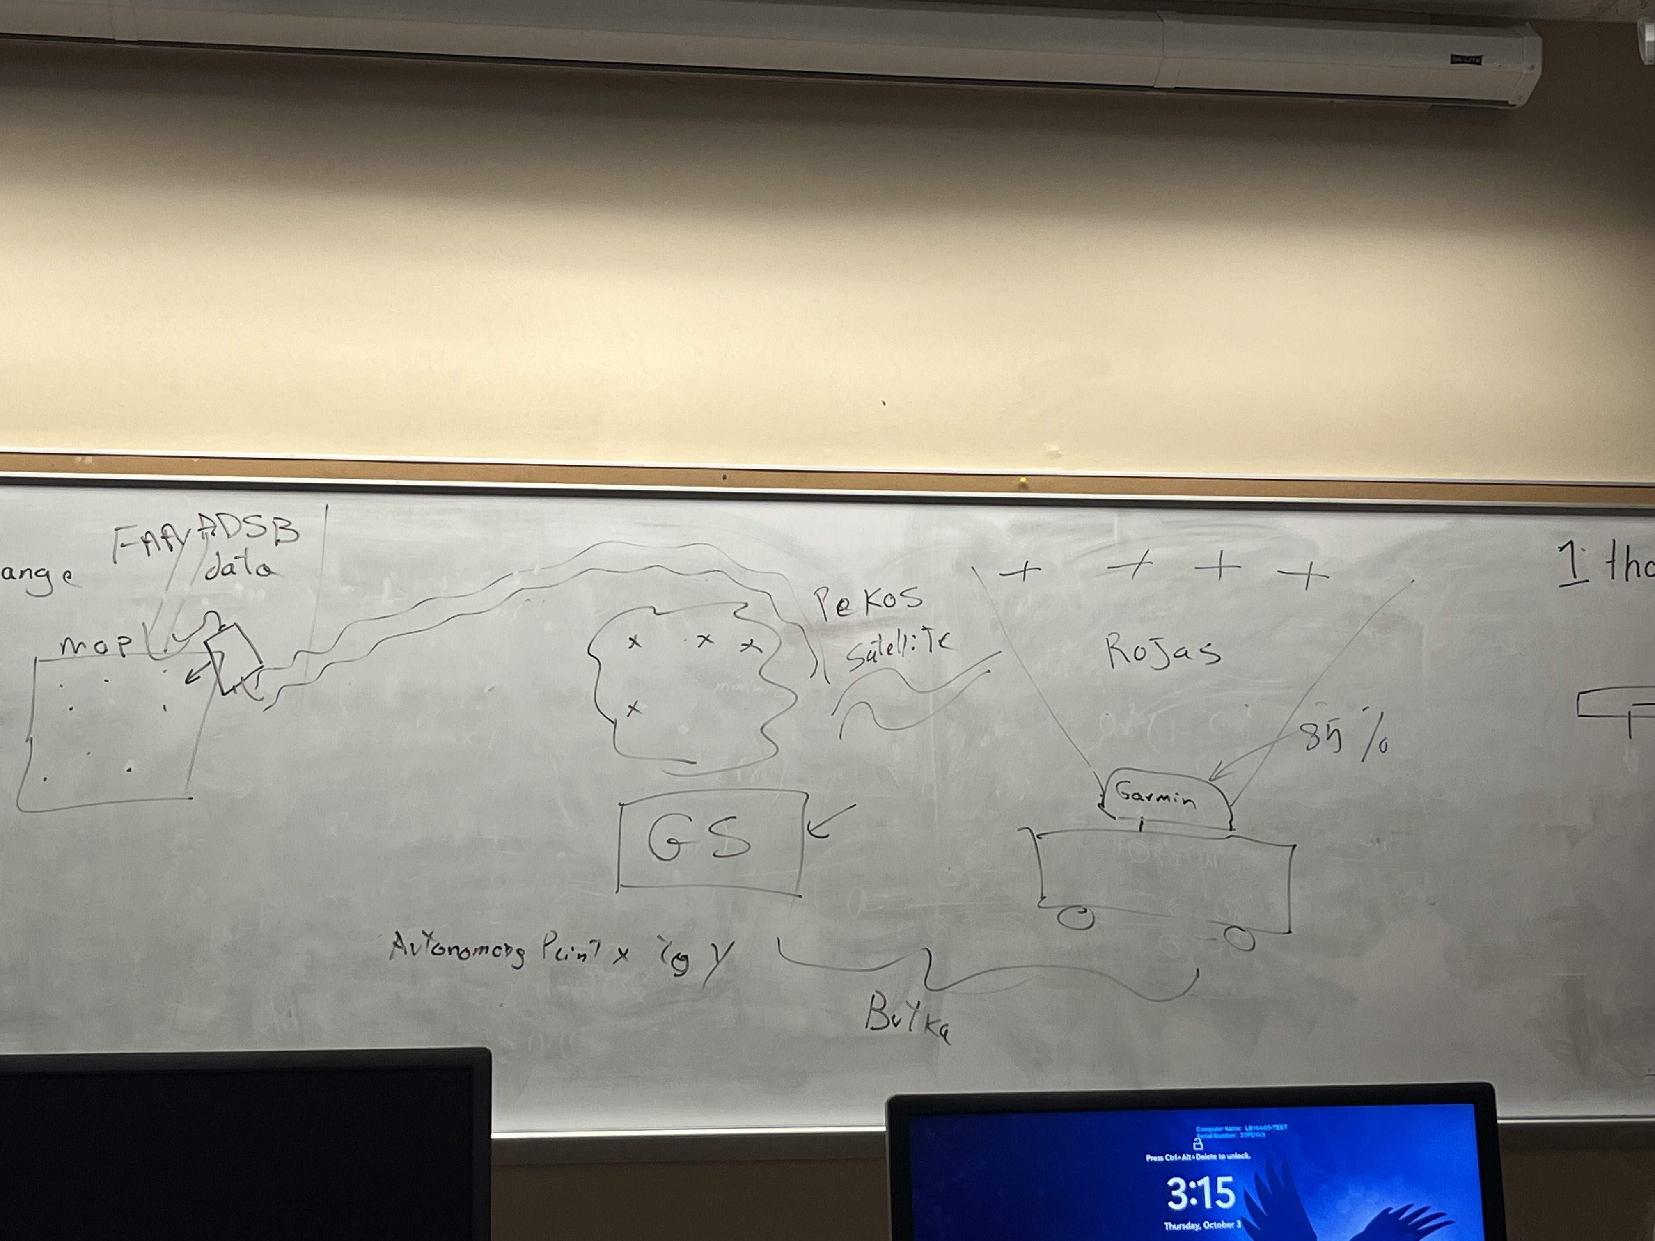

10/09/24:

Did some research into satellites and radars that we can use for UAVS/planes. It is definitely going to be a little bit more complicated if we go along with this new scope based on the research, but it can definitely be done.

I also worked on requirements for the robot. Very generic ones but allowed us to get a rough idea on what the main focuses should be for us as a team.

I also did some work on the presentation and finished up the hardware section before the hurricane hit.

10/18/24:

Solidified the robotic arm we are going to order and sent it to the group via discord. The arm is very mobile, and the end can easily be taken off to add the temp sensor to read the body's temperature. Also, the weight of the arm will counteract the weight of the battery since we plan to have the arm in the front of the robot and the battery in the back.

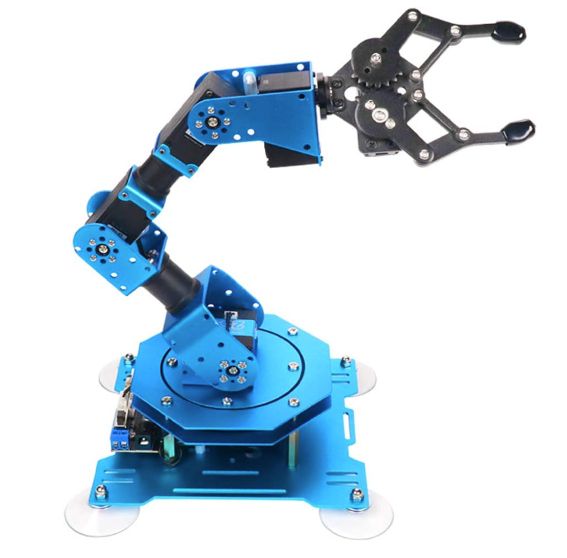

10/21/24:

Today I worked on more requirements due to having to delete some from the research that I did on satellites and UAVs. The requirements will be a work in progress as we do more work on the robot but so far, they have created a solid base to build from.